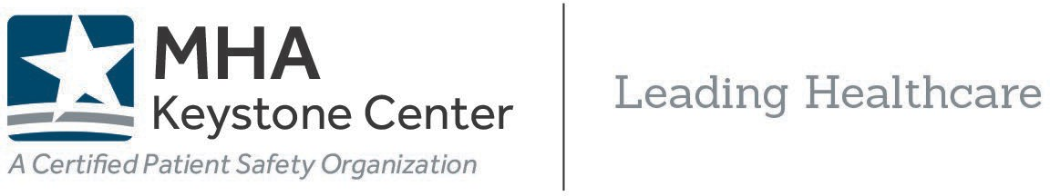

Michigan Maternal Health Quality Improvement Support
Maternal Levels of Care (MLC) Verification Cost Coverage
Updated 1.15.26

Background
The Michigan Department of Health and Human Services (MDHHS) is providing Fiscal Year 2026 Hospital Maternal Health Quality Payments to birthing hospitals who participate in the Michigan Alliance for Innovation on Maternal Health (MI AIM) collaborative and have committed to The Joint Commission’s Maternal Levels of Care (MLC) Verification Program.

To receive the quality payments in 2026, Michigan birthing hospitals must meet specific AIM and MLC requirements by July 31, 2026. Visit the MHA website to review quality payment requirements for 2026.
This opportunity also includes coverage of hospital costs associated with The Joint Commission’s MLC Verification.

MLC Verification Cost Coverage
The costs associated with MLC verification – including the annual fee for a period of three
(3) years and the on-site verification fee (once per three years) – are covered by MDHHS via the MHA Keystone Center.

Hospitals apply for the MLC verification through TJC’s Connect portal. Upon submitting the verification application, TJC will generate MLC invoices and post to the hospital’s TJC Connect portal. For more information about the application and verification process, visit the MHA MLC toolkit.

TJC MLC Invoicing Process – What to Expect
The initial invoice for the verification will cover a partial year for applications submitted after the first calendar quartile. Subsequent invoices will reflect the full annual fee for the verification program. On-site review fees will be invoiced shortly after a scheduled visit.

Hospitals should NOT pay any invoice associated with MLC verification. TJC will notify the MHA Keystone Center when invoices for Michigan hospital applicants are generated. Invoices will continue to post to your TJC Connect portal. The MHA Keystone Center will cover the invoices related to the MLC fees outlined below, on behalf of the hospital, directly to TJC. Invoices will be submitted to the MHA the month following their creation. Late fees will not be assessed for Michigan MLC verification services.

Please note TJC Connect portal users may receive automatic reminders through the portal to pay the MLC invoice(s). These are generated automatically and should be ignored. Please communicate this with team members and TJC’s Connect portal users.
The Joint Commission Verification Program Costs – 2026

Maternal Level of Care | Annual Fee | Onsite Review Fee | Total 3-year Fee Covered
Level 1: Basic Care | $2,060 (x3 years) | $2,415 (x1 visit) | $8,595
Level 2: Specialty Care | $3,090 (x3 years) | $2,415 (x1 visit) | $11,685
Level 3: Subspecialty  Care | $5,150 (x3 years) | $3,445 (x1 visit) | $18,895
Level 4: Regional Perinatal Health Care  Centers | $6,180 (x3 years) | $3,445 (x1 visit) | $21,985

