COVID-19 Social Media Toolkit, Spring/Summer 2021
Spring Surge Messaging……………………………………………………………………Pg. 1
Johnson & Johnson Pause Messaging……………………………………………….Pg. 2
Pediatric Hospitalizations & MIS-C Messaging…………………………….......Pg. 2-3
COVID Breakthrough Case Messaging……………………………………………….Pg. 3
Vaccine Sign-Up & Waitlist Messaging………………………………………………Pg. 4-5
Vaccine Facebook/Twitter Banner…………………………………………………….Pg. 5
COVID-19 Testing Awareness/Info…………………………………………………….Pg. 6
Post-Vaccine Symptoms & Public Protocol………………………………………..Pg. 6-7
Spring/Summer Travel Messaging…………………………………………………....Pg. 7-8
B.1.1.7 Variant Messaging……..………………………………………………………….Pg. 9
Hospital Safety Messaging……..………………………………………………………….Pg. 9
Antibody Treatment Messaging……..…………………………………………..…….Pg. 10

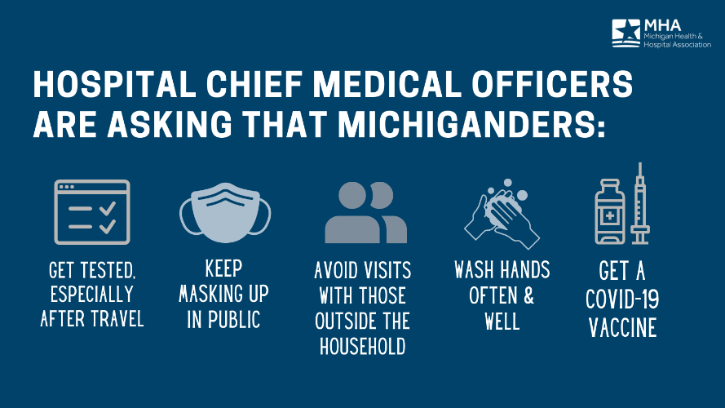
Spring Surge Messaging:
Graphic 1: Michigan hospital chief medical officers are urging Michiganders to get vaccinated and continue public safety measures amid the latest #COVID19 surge. Read more: https://bit.ly/2OFLTU4

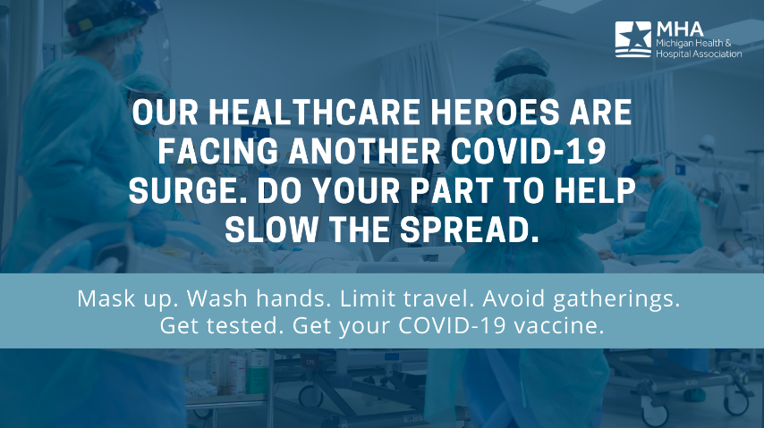
Graphic 2: As #COVID19 continues to spread in Michigan, our healthcare heroes need your help. Learn more: https://bit.ly/2OFLTU4

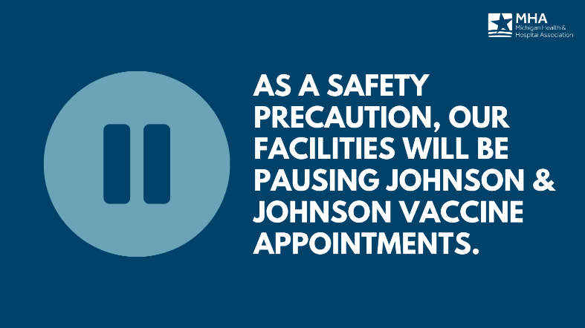
Johnson & Johnson Pause Messaging:
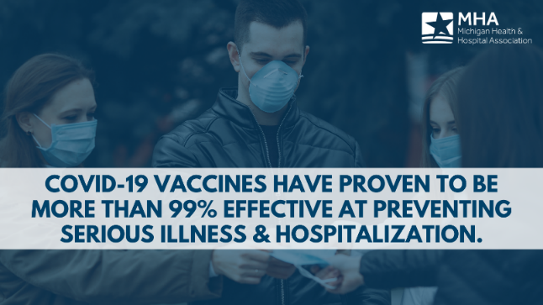
Graphic 1: Our facilities are aware of the Johnson & Johnson COVID-19 vaccine pause and will communicate updates as they are available. In the meantime, it’s important to remember that the COVID-19 vaccines are more than 99% effective at preventing serious illness and hospitalization. Learn more from the @CDC: https://bit.ly/3qeIhos

Graphic 2 & 3: Though serious, adverse side effects to the #COVID19 vaccines are rare. Following the @JNJNews pause, federal agencies are investigating less than 10 instances of side effects out of more than 6.8 million doses administered. Learn more from the @CDC: https://bit.ly/3qeIhos
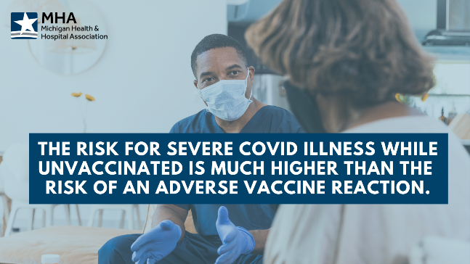

Pediatric Hospitalizations & MIS-C:
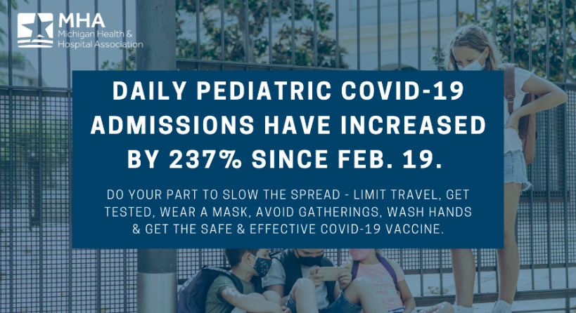
Graphic 1: As pediatric #COVID19 hospitalizations are at record levels in Michigan, do your part to help slow the spread. Learn more: https://bit.ly/2OFLTU4

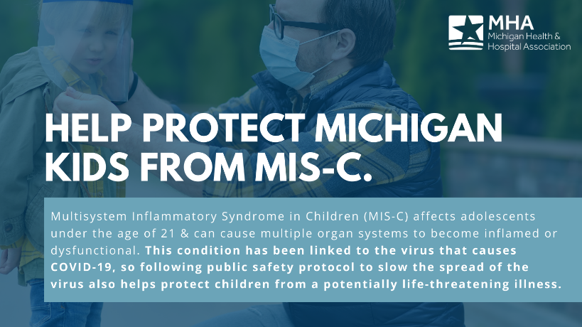
Graphic 2: Health experts are becoming increasingly concerned by cases of Multisystem Inflammatory Syndrome in Children (MIS-C), which has been linked to the COVID-19 virus. Learn more: https://bit.ly/3sblQlp
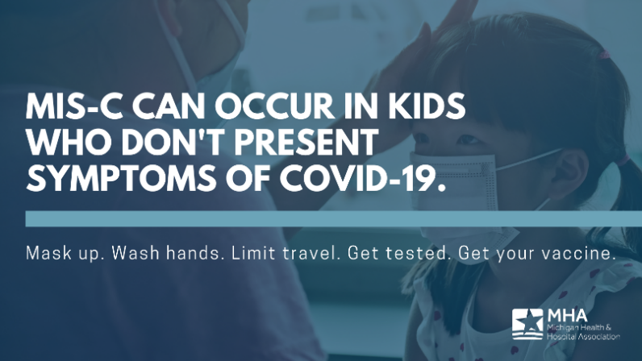
Graphic 3: Multisystem Inflammatory Syndrome in Children (MIS-C) affects adolescents under the age of 21 and has been linked to various cases of #COVID19. Learn more about what you can do to help slow the spread: https://bit.ly/3sblQlp

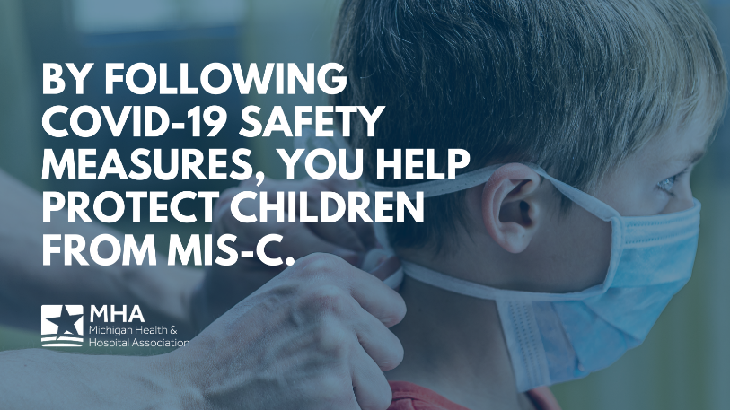
Graphic 4-5: Following the safety measures we know slow the spread of #COVID19 also protects children from serious cases of Multisystem Inflammatory Syndrome in Children (MIS-C). Learn more: https://bit.ly/2OFLTU4

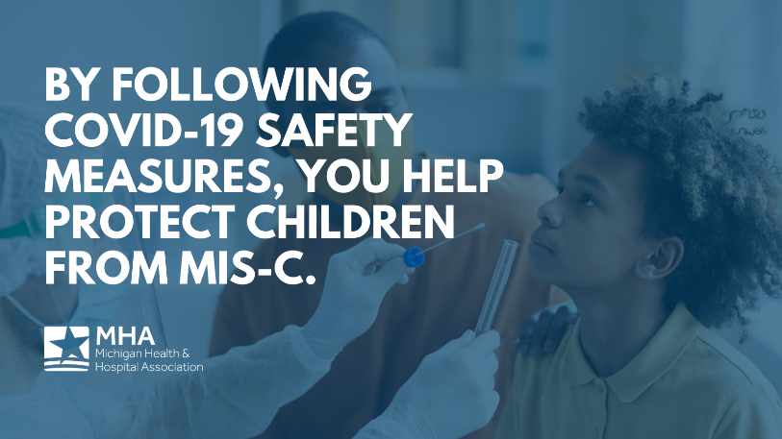

COVID Breakthrough Case Messaging
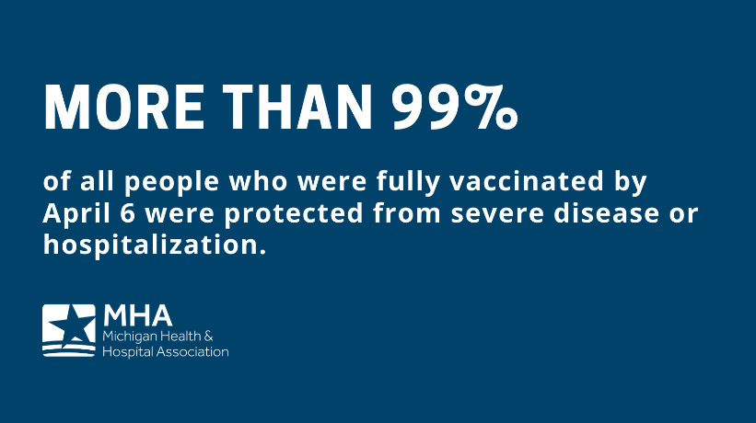
Graphic 1: Breakthrough COVID-19 cases are one of the reasons to stay vigilant with masking up, washing hands, limiting travel & social distancing – but it’s important to look at the numbers & recognize the overall effectiveness of these vaccines. Learn more: https://bit.ly/3aesEsc

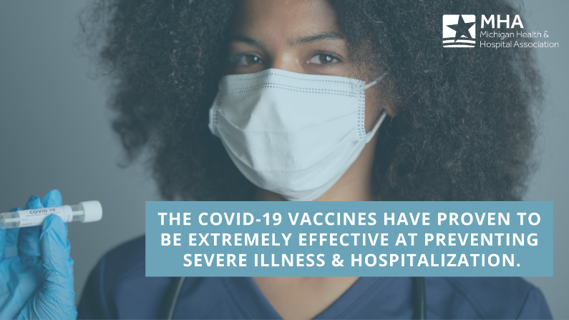
Graphic 2: The more people vaccinated against #COVID19, the better. Breakthrough cases post-vaccine should be taken seriously, but are rare. Learn more: https://bit.ly/3tnAk2V

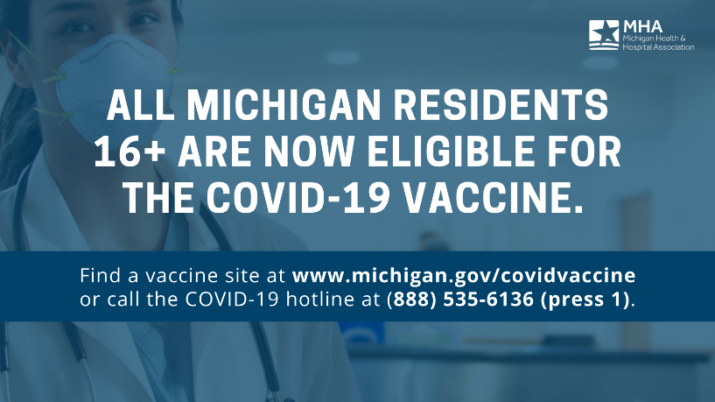
Vaccine Sign-Up & Waitlist Messaging:
Graphic 1: Michiganders 16+ are now eligible and encouraged to receive the #COVID19 vaccine in Michigan as soon as possible. Find a site near you here: https://bit.ly/3wXM8uJ

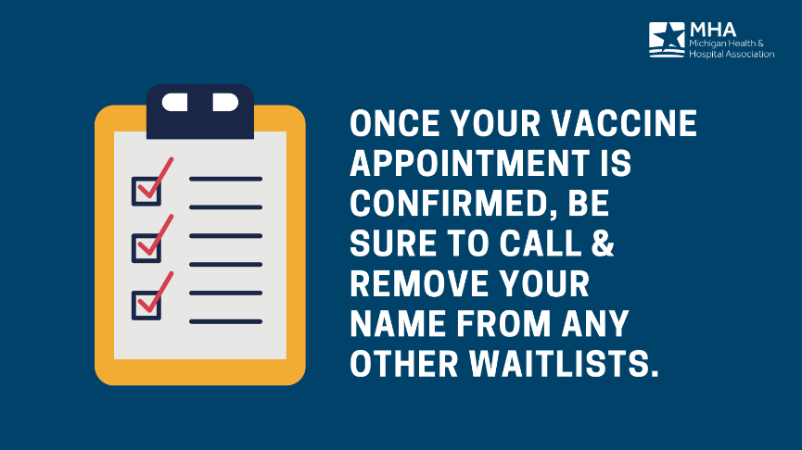
Graphic 2: Remember: If you’re on multiple waitlists to get the #COVID19 vaccine, be sure to call and remove your name once an appointment is booked. #doseofhope

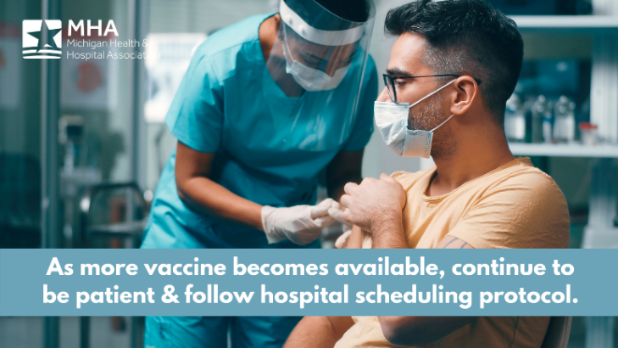
Graphic 3: Our hospital will continue to be a partner in vaccination efforts, and we appreciate your patience and cooperation. Those looking to schedule a #COVID19 vaccine can call the local health department or visit our website for more information: [INSERT LINK]
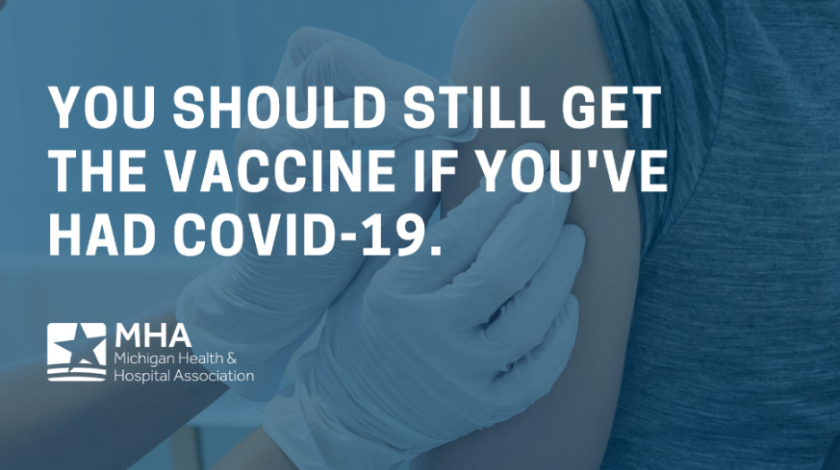
Graphic 4: Getting vaccinated is a safer way to build protection than getting infected and recovering from #COVID19. Learn more from the @CDCgov: https://bit.ly/37aivMc #DoseofHope

Graphic 5: Anyone receiving a two-dose COVID-19 vaccine should NOT skip their second dose. Full immunity is important to protect yourself and those who are still vulnerable.

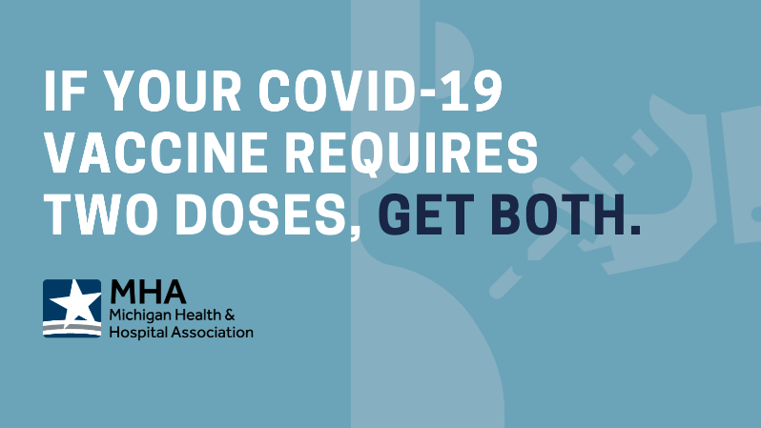

COVID-19 Vaccine Facebook/Twitter Banner:
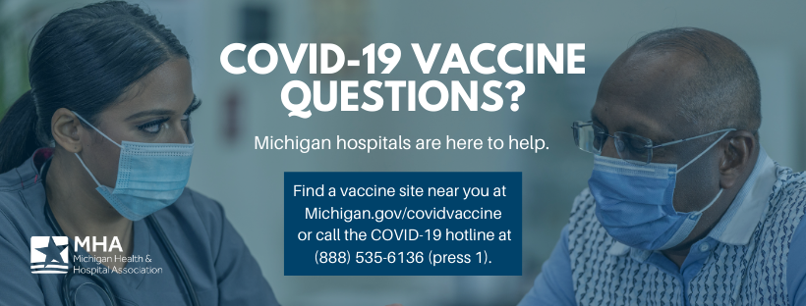

COVID Testing Awareness/Info:
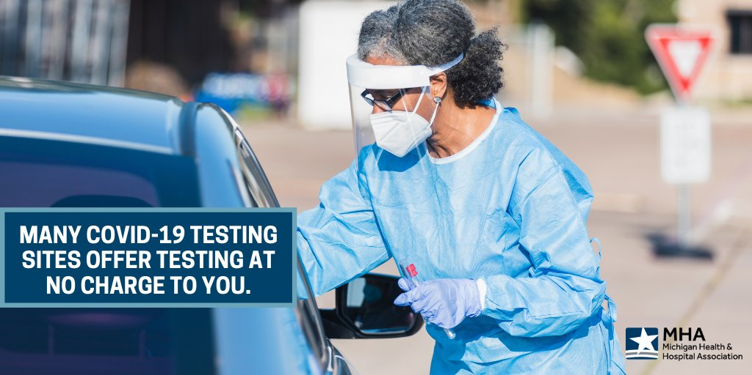
Graphic 1: Getting tested for #COVID19, even if you are not experiencing symptoms, helps protect you, your loved ones & others from the risk of severe illness. Find a testing site near you here: https://bit.ly/2OIgKPR

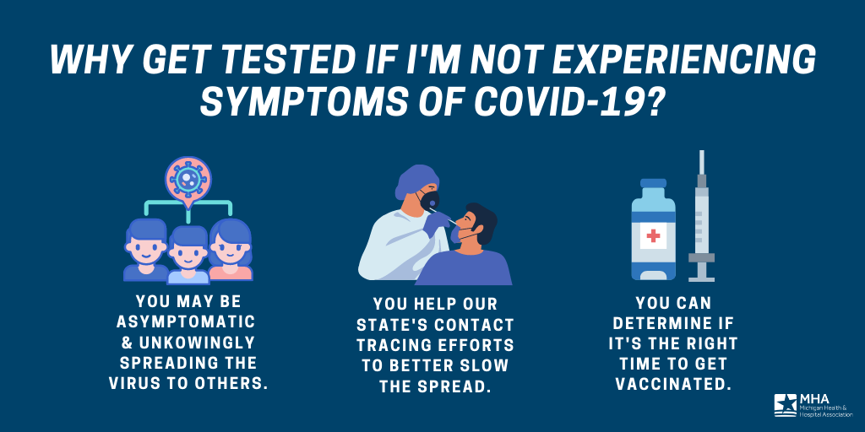
Graphic 2: Find a testing site near you to help slow the spread of COVID-19 in Michigan: https://bit.ly/2OIgKPR

Post-Vaccine Symptoms & Public Protocol:
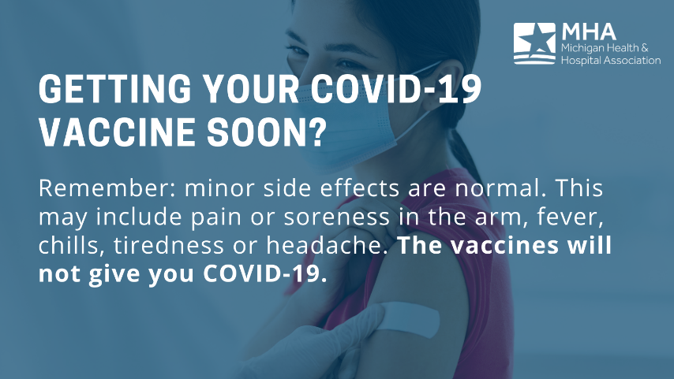
Graphic 1: It’s important to know the facts about the COVID-19 vaccines to keep yourself and your loved ones informed. Find more answers to frequently asked questions here: https://bit.ly/3ccQkPk

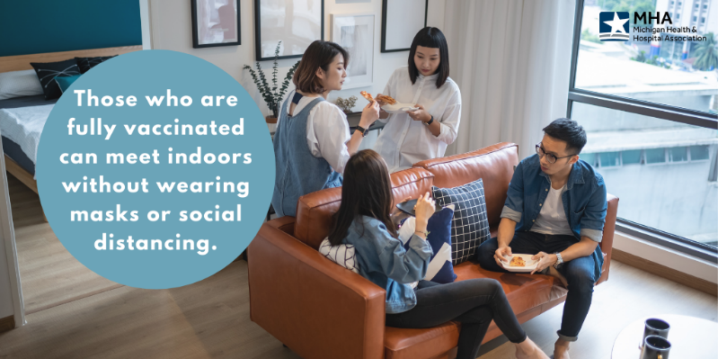
Graphic 2: The CDC offers public safety guidance for those who are fully vaccinated against #COVID19. Learn more: https://bit.ly/3t0Z5RQ

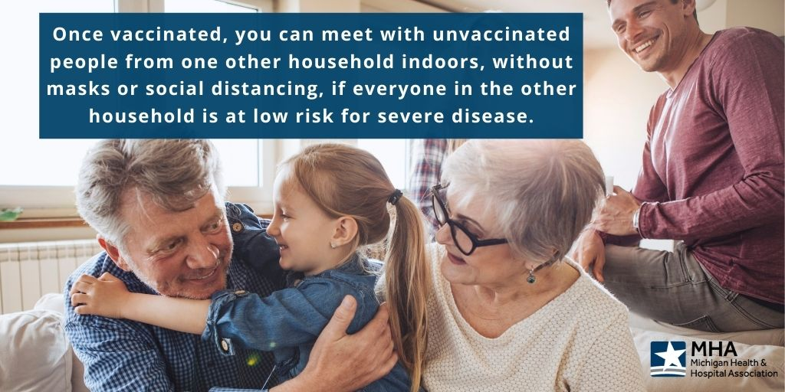
Graphic 3: As more people get vaccinated against COVID-19, the CDC will continue to provide guidance to help fully vaccinated people safely resume normal activities. Learn more: https://bit.ly/3t0Z5RQ

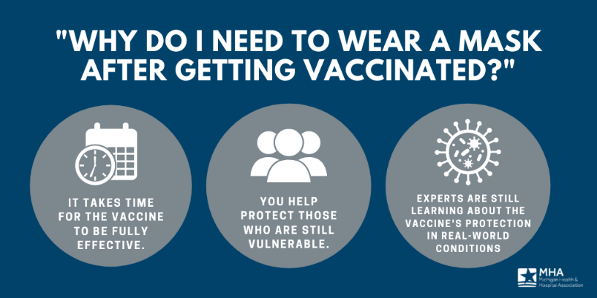
Graphic 4: Fully vaccinated? You should continue COVID-19 precautions in public with unvaccinated people from other households and unvaccinated people who are at high risk of severe illness. Learn more from the CDC: https://bit.ly/3t0Z5RQ

Spring/Summer Travel Messaging:
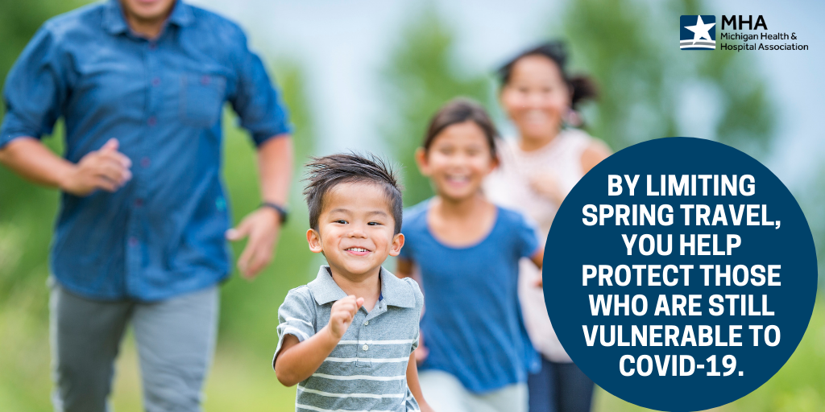
Graphic 4: As vaccine allocations continue, limiting travel will help protect those who are still vulnerable to #COVID19. Learn more: https://bit.ly/36VSFrU

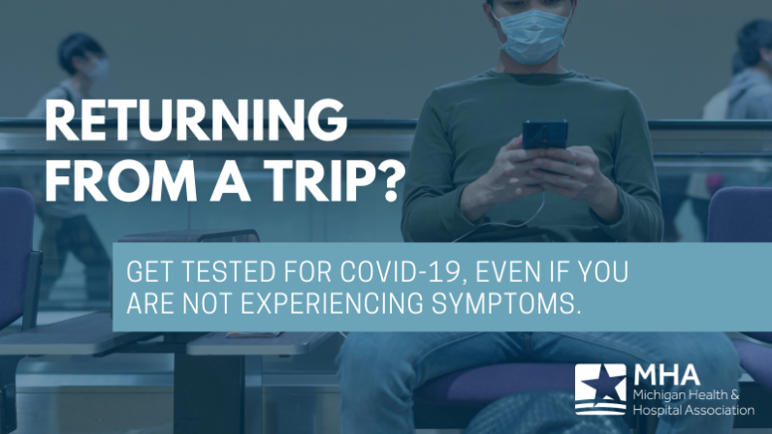
Graphic 5 & 6: If you traveled, are symptomatic or have been exposed to #COVID19, get tested as soon as possible to protect your own family and others from the risk of severe illness. Find a testing site near you here: https://bit.ly/2OIgKPR

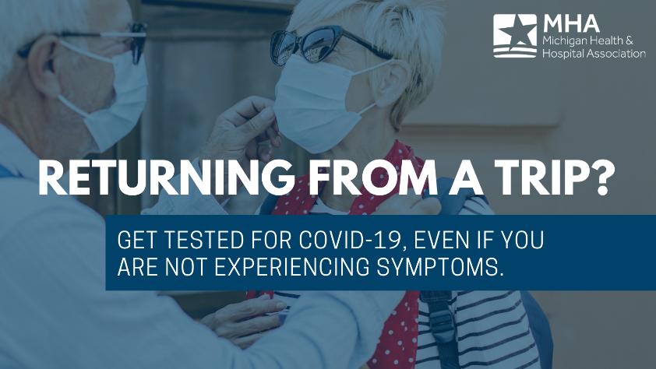

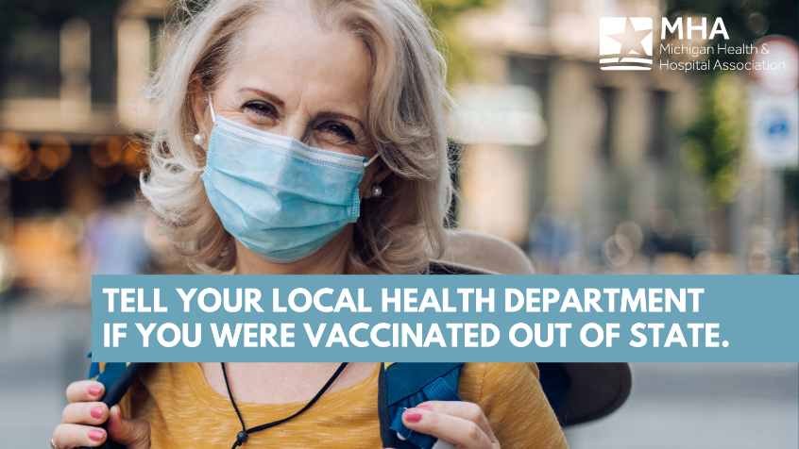
Graphic 7 & 8: Traveling back to Michigan? Be sure to inform your doctor or local health department if you received a #COVID19 vaccine out of state to help accurately report our vaccinated population.

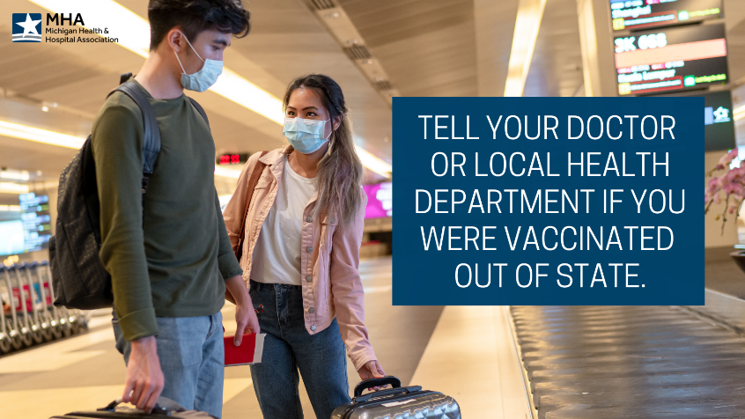

B.1.1.7 Variant Messaging:
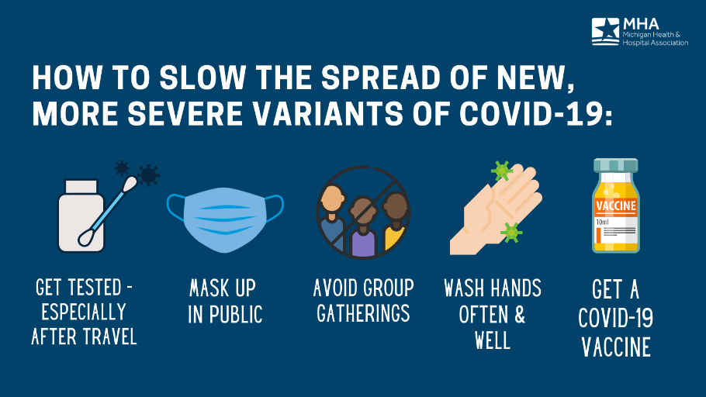
Graphic 1: As we learn about new variants of COVID-19 that cause severe illness and spread more easily, follow the public safety practices that keep you, your loved ones & the community safe.

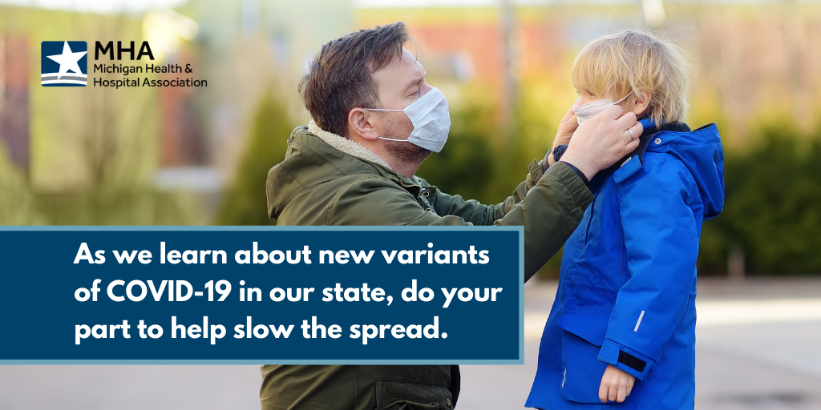
Graphic 2: Limiting travel, wearing a mask, washing hands & getting vaccinated as soon as possible are all steps you can take to help slow the spread of #COVID19. Learn more: http://bit.ly/3ct5yQ3

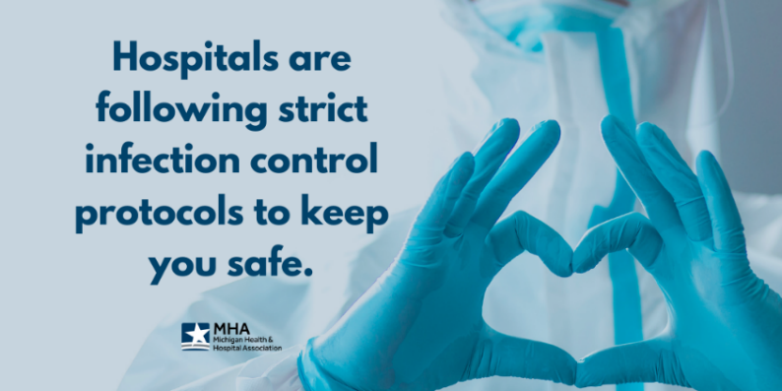
Hospital Safety Messaging:
Graphic 1: Our facilities are a safe place for care whether you’re seeking COVID-19 treatment or not. All healthcare workers are taking extensive safety measures to protect themselves and their patients.

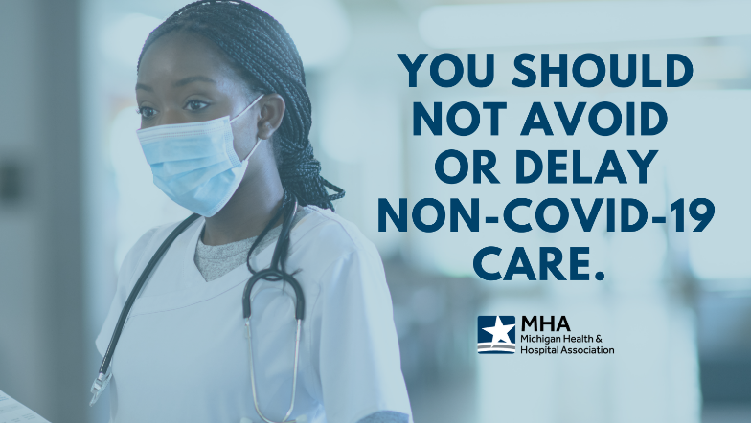
Graphic 2: The latest #COVID19 surge is not a reason to put off necessary, non-COVID-19 care. If you are experiencing a medical emergency, seek care immediately.

Antibody Treatment Messaging:
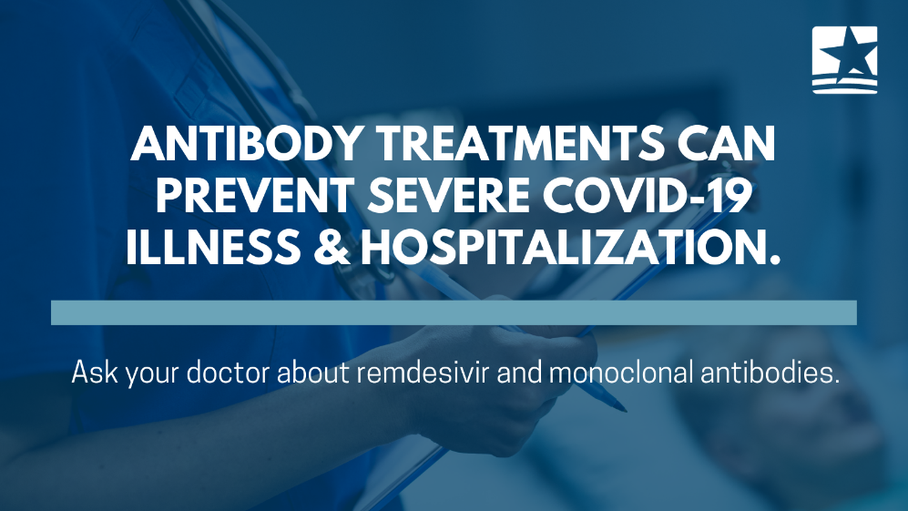
Graphic 1: The @NIH COVID-19 Treatment Guidelines Panel strongly recommends therapeutic medications for patients at high risk of severe #COVID19. Learn more: https://bit.ly/3dlROqN

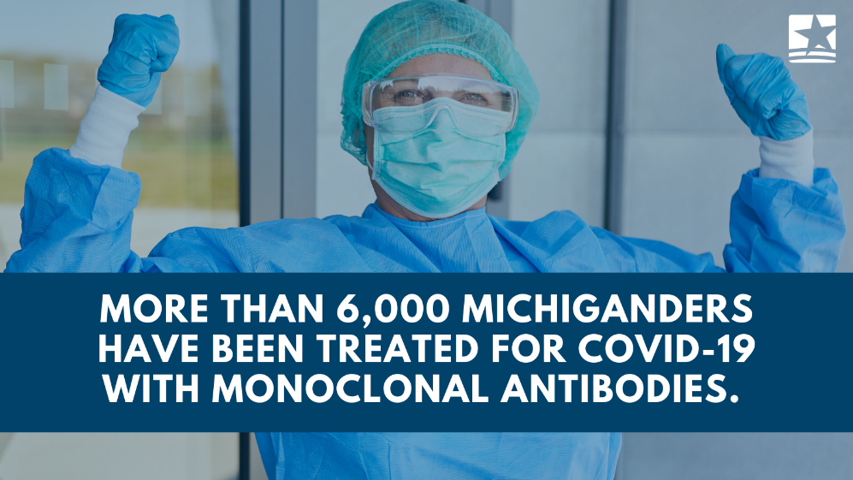
Graphic 2: Early trial data on therapeutic medications suggests a 70% reduction in COVID-19 hospitalizations. Ask your doctor about remdesivir and monoclonal antibodies.

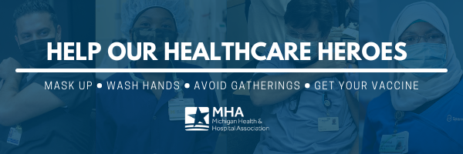
MHA/COVID-19 E-mail Signature Graphic:

