COVID-19 Social Media Posts, Summer-Fall 2021
- Delta Variant Messaging…………………………………………………………………………..….…Pg. 1
- Masking Guidance……..……………………………………………………………………………………Pg. 2
- Back-to-School/Immunization Awareness………………..……………………………….……Pg. 3-4
- General Vaccine Infographics/FAQs…………………………………………………………..……Pg. 4-5
- Third Dose Messaging…………………………………………………………………………..…………Pg. 6

Delta Variant Messaging –
Twitter: The #COVID19 vaccine is the best way to protect yourself and others from the fast-spreading delta variant, which has caused over 80% of recent cases in the U.S. according to the @CDC. Learn more: https://bit.ly/3CwuJfK
Twitter: Leading health experts in our state and country are continuing to urge the public to get vaccinated to protect themselves against the highly contagious #COVID19 delta variant, which can lead to severe illness and hospitalization for those who are not protected.
Facebook: Leading health experts have found that the COVID-19 delta variant is much more contagious and poses a serious threat to those who are not vaccinated. Wearing a mask in crowded, high transmission areas until you’re able to get the vaccine protects you and others. Learn more: https://bit.ly/3iYy3Hr
Facebook: The COVID-19 vaccine is our best defense against the delta variant, which spreads about 225% faster than the original version of the virus and replicates at much higher levels inside the respiratory tract. Learn more: https://bit.ly/3CwuJfK
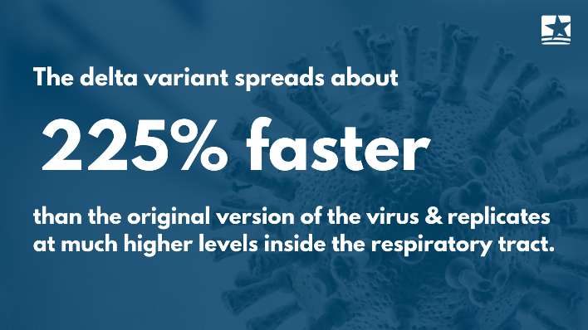
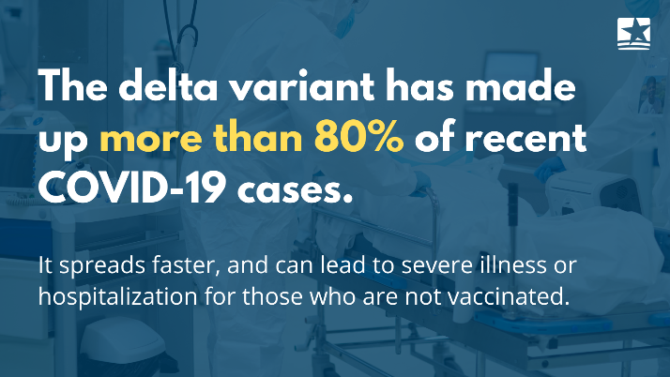
Graphics:

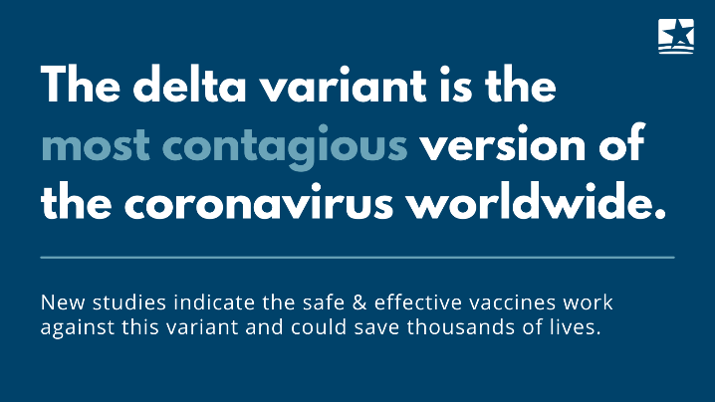
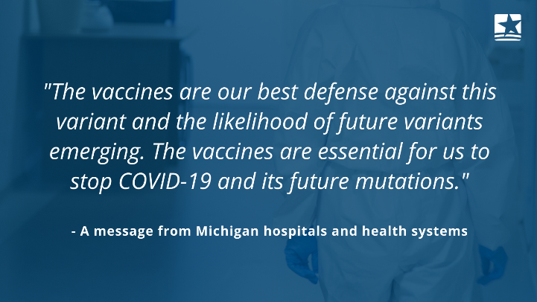

Masking Guidance
Twitter: Many people, including young children, are still vulnerable to #COVID19. Vaccinated or not, wearing a mask indoors protects those who are still susceptible to severe illness. To find a vaccine site near you, visit: https://bit.ly/337iSUB
Twitter: Continuing to #MaskUp indoors & in areas of high transmission keeps you, your loved ones & the community safe from #COVID19 and the dangerous delta variant. Learn more: https://bit.ly/CDTlevels
Facebook: Vaccinated or not, Michigan medical experts are encouraging everyone to wear a mask indoors to help slow the spread & protect those who are still susceptible to severe illness or hospitalization. Learn more: https://bit.ly/CDTlevels
Facebook: Masking in areas of high transmission keeps you, your loved ones and the community safe from the spread of #COVID19 and its dangerous variants – especially those who haven’t been, or can’t be, vaccinated yet. Interested in signing up for an appointment? Visit: https://bit.ly/337iSUB
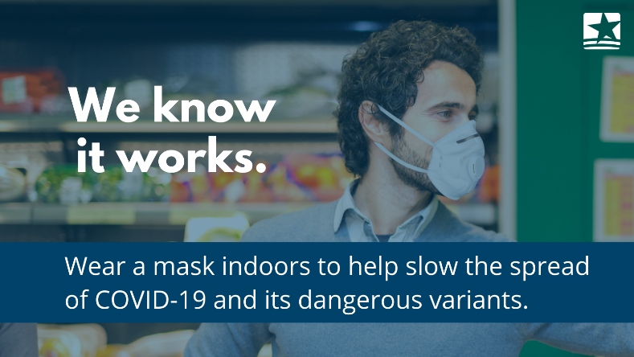
Graphics:
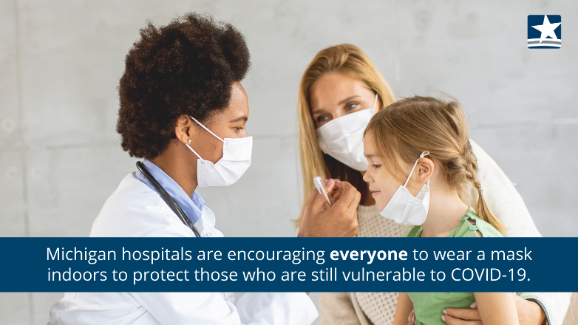
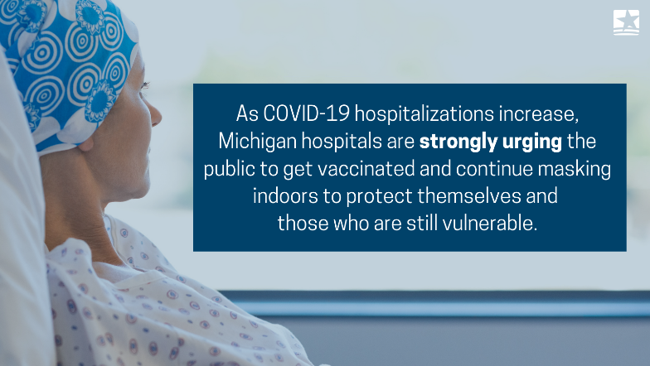
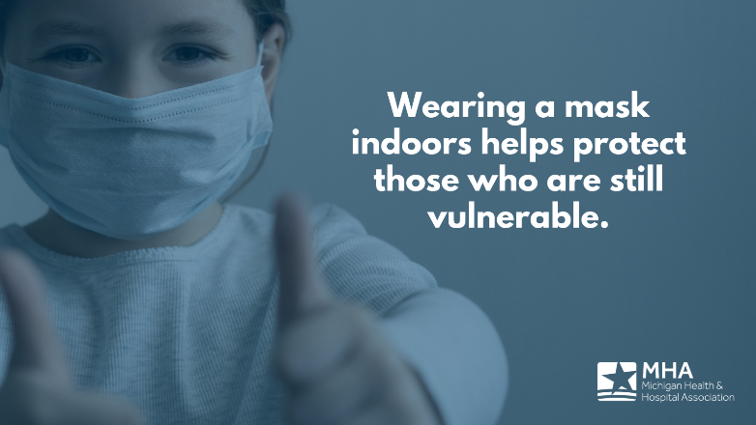

Back-to-School / Childhood Immunizations / Immunization Awareness Month –
Twitter: As schools, child care centers and extracurriculars resume, parents should schedule a checkup as soon as possible to stay up to date on necessary immunizations and routine health screenings. Learn more: https://bit.ly/2TPNAkc
Twitter: Want to make sure your child receives the #COVID19 vaccine once they are eligible? Now’s the time to ask questions and discuss the safety and efficacy of the vaccine with a doctor or pharmacist to create a care plan that’s right for your family.
Twitter: August is #ImmunizationAwareness Month – now's the time to schedule a back-to-school checkup to protect children from preventable diseases and ask questions about the #COVID19 vaccine before eligibility expands to younger age groups.
Facebook: Childhood immunizations are key to preventing harmful diseases. To avoid outbreaks of vaccine-preventable diseases, now is the time to make sure your child is vaccinated before resuming in-person learning. #ImmunizationAwareness Month: https://bit.ly/2TPNAkc
Facebook: Before in-person learning resumes, schedule a checkup for routine screenings and bring your questions about the COVID-19 vaccine - even if your child is not eligible yet. Getting up to date, accurate information from a doctor is critical to protecting loved ones from the virus and its fast-spreading variants.
Facebook: With school starting up in a few short weeks, be sure your child is up to date on all routine immunizations. If they're behind on their shots, call your pediatrician's office to make an appointment. Learn more: https://bit.ly/2TPNAkc
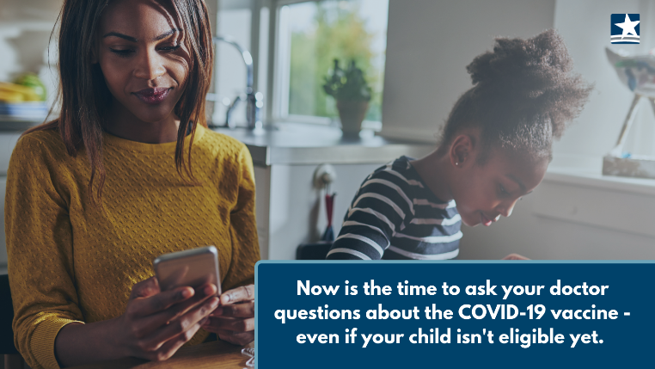
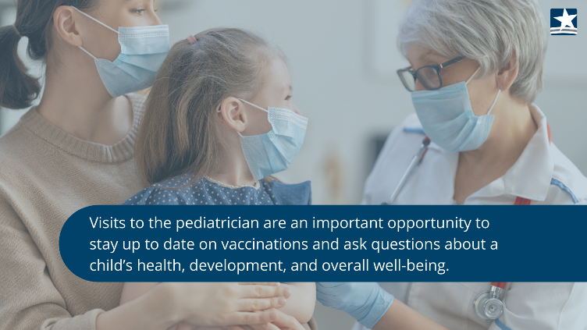
Graphics:

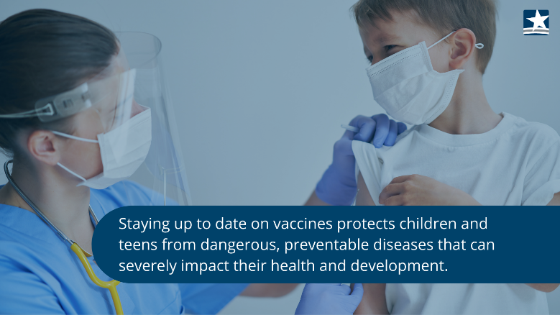
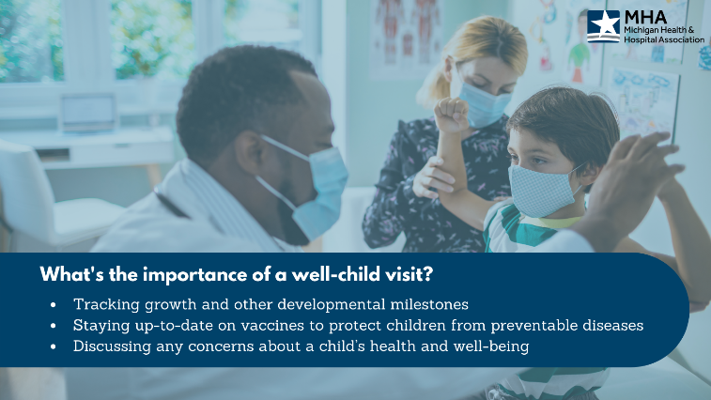

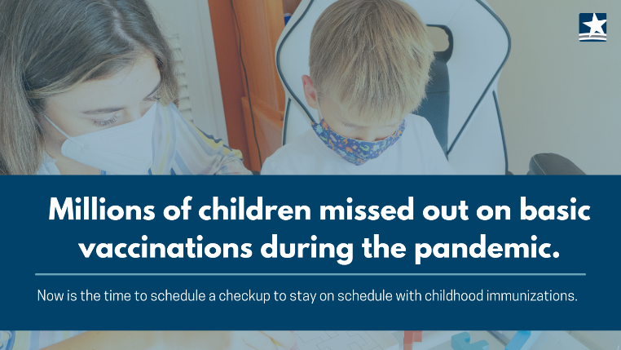
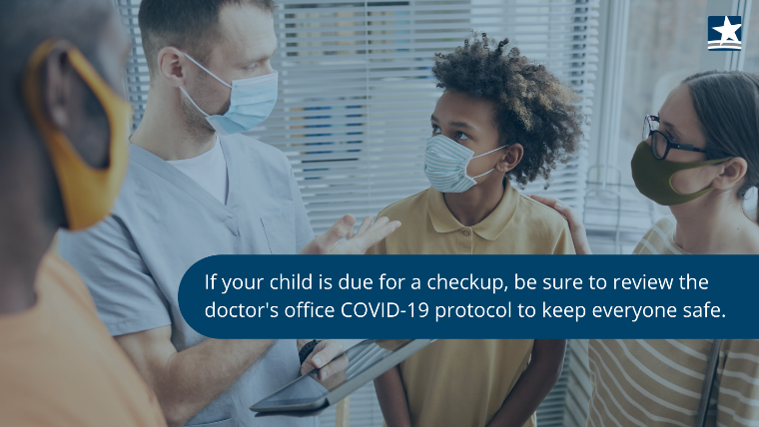

General Vaccine Info –
Twitter: Questions about the #COVID19 vaccines? Doctors, nurses, pharmacists, and your local hospitals and health departments are here to help.
Twitter: It’s safe and recommended to get a #COVID19 vaccine - even if you’ve had COVID-19. In fact, individuals who’ve had the virus are 2.34 times more likely to be reinfected than those who are fully vaccinated. Learn more: https://bit.ly/37aivMc
Facebook: Our healthcare heroes want you to stay healthy and out of the hospital. The best way to reduce pressure on hospital staff is to get the safe and effective COVID-19 vaccine.
Facebook: Together our actions will serve the public good, save lives and shorten the health and economic impact of the pandemic. Learn more: https://bit.ly/37aivMc
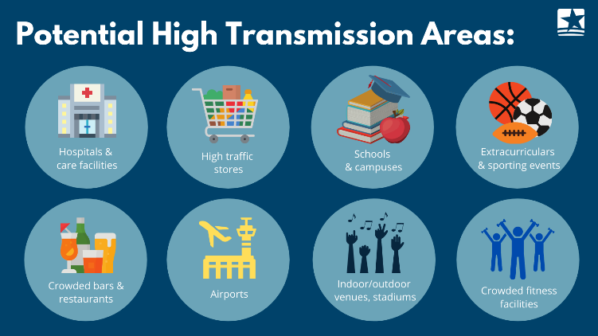
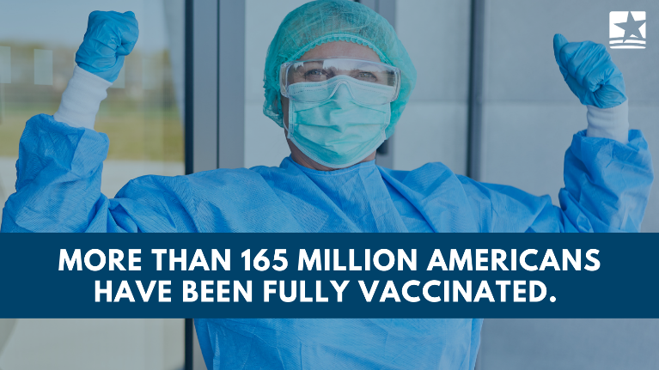
Graphics:

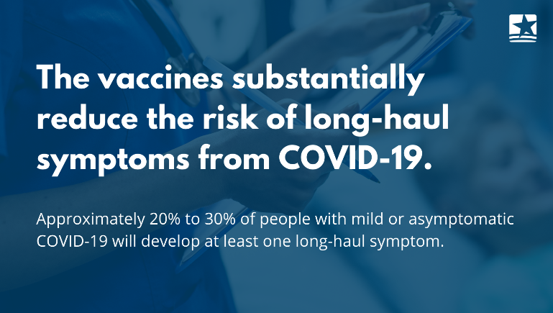
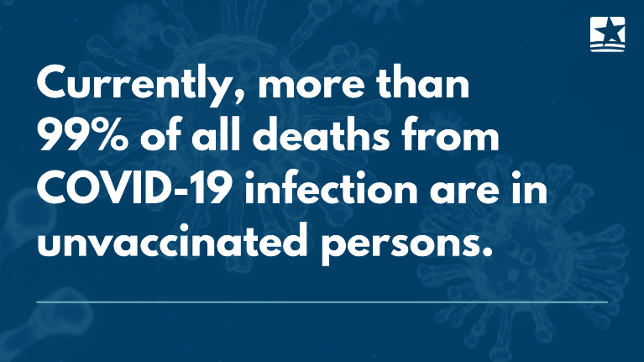
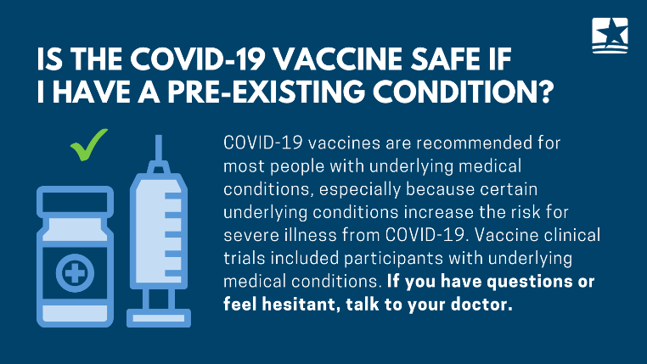
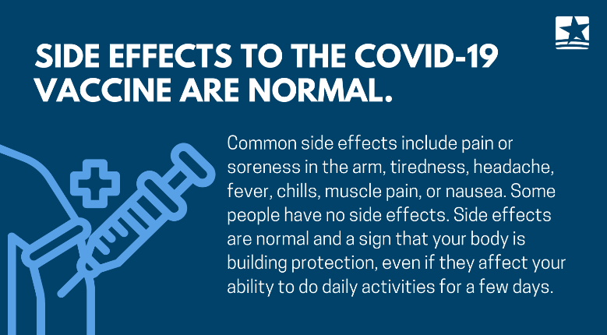
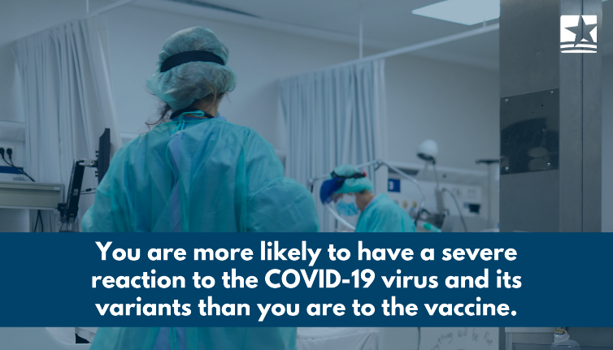
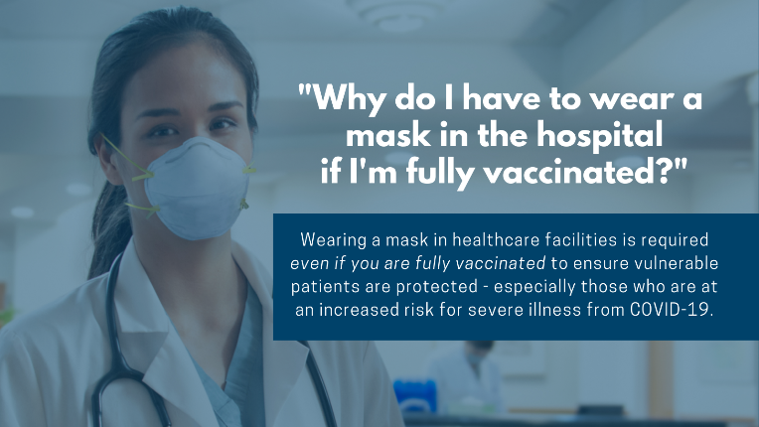
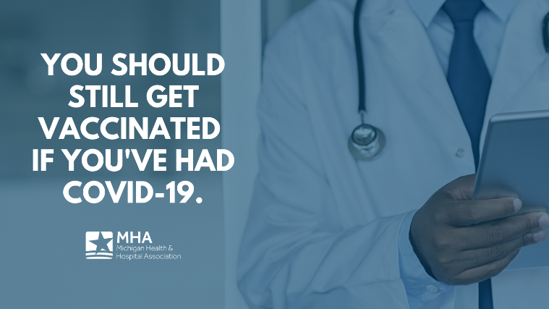
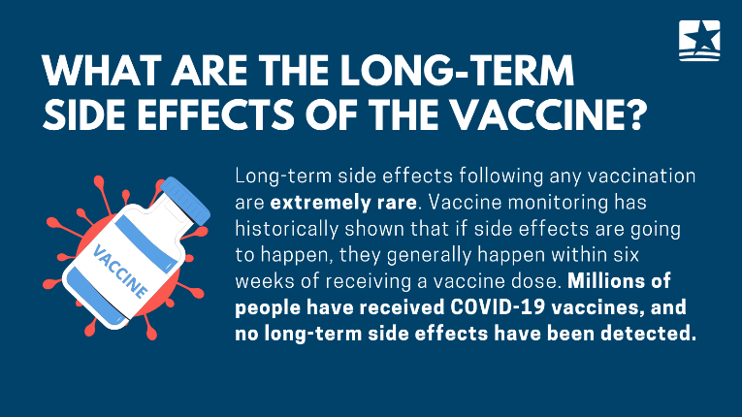
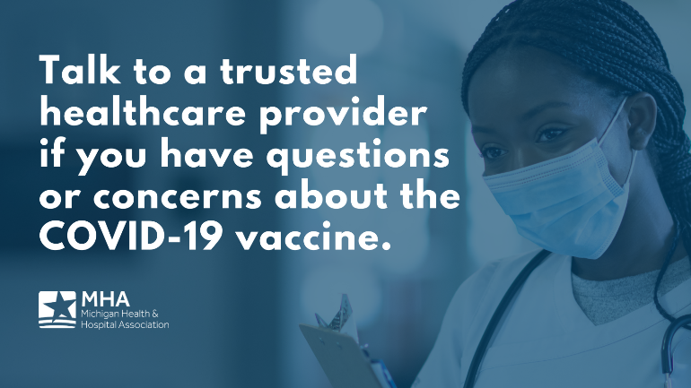

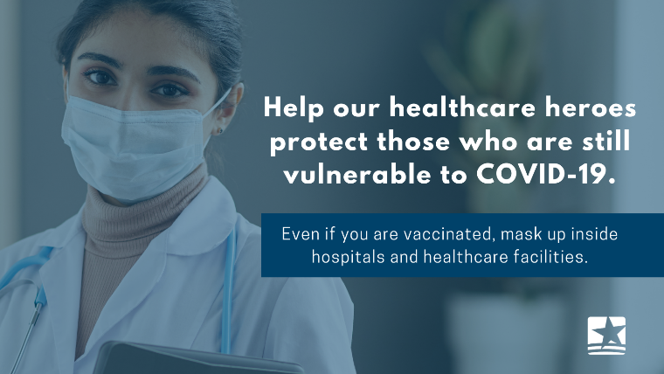

Third Dose Messaging –
Twitter: Health officials currently recommend a third dose of the COVID-19 #vaccine for at-risk patients and those with a weakened immune system. Eligibility is expected to expand in the coming weeks. Learn more: https://bit.ly/3xPmeZy
Twitter: Curious if you’re eligible for a third dose of the #COVID19 vaccine? Talk to a trusted healthcare provider to ask questions or learn more.
Facebook: U.S. health officials are currently recommending a third dose of the COVID-19 vaccine for those with weakened immune systems, including cancer patients and organ transplant recipients. Eligibility is expected to expand in the coming weeks. Learn more: https://bit.ly/3xPmeZy
Facebook: Curious if you’re eligible for a third dose of the COVID-19 vaccine? Talk to a trusted healthcare provider if you have questions or would like to learn more.
Graphics:
